Spring REST using Spring Boot 3

3.Hello World RESTful Web Service

**WebConfig.java:**

package com.cognizant.springlearn.config;

import org.springframework.context.annotation.ComponentScan;

import org.springframework.context.annotation.Configuration;

import org.springframework.web.servlet.config.annotation.EnableWebMvc;

@Configuration

@EnableWebMvc

@ComponentScan(basePackages = "com.cognizant.springlearn")

public class WebConfig {

}

**HelloController.java:**

package com.cognizant.springlearn.controller;

import org.slf4j.Logger;

import org.slf4j.LoggerFactory;

import org.springframework.web.bind.annotation.GetMapping;

import org.springframework.web.bind.annotation.RestController;

@RestController

public class HelloController {

private static final Logger *LOGGER* = LoggerFactory.*getLogger*(HelloController.class);

@GetMapping("/hello")

public String sayHello() {

*LOGGER*.info("START sayHello()");

*LOGGER*.info("END sayHello()");

return "Hello World!!";

}

}

**WebAppInitializer.java:**

package com.cognizant.springlearnn;

import com.cognizant.springlearn.config.WebConfig;

import org.springframework.web.WebApplicationInitializer;

import org.springframework.web.context.support.AnnotationConfigWebApplicationContext;

import org.springframework.web.servlet.DispatcherServlet;

import javax.servlet.ServletContext;

import javax.servlet.ServletException;

import javax.servlet.ServletRegistration;

public class WebAppInitializer implements WebApplicationInitializer {

@Override

public void onStartup(ServletContext servletContext) throws ServletException {

AnnotationConfigWebApplicationContext context = new AnnotationConfigWebApplicationContext();

context.register(WebConfig.class);

ServletRegistration.Dynamic dispatcher = servletContext.addServlet("dispatcher", new DispatcherServlet(context));

dispatcher.setLoadOnStartup(1);

dispatcher.addMapping("/");

}

}

**OUTPUT:**

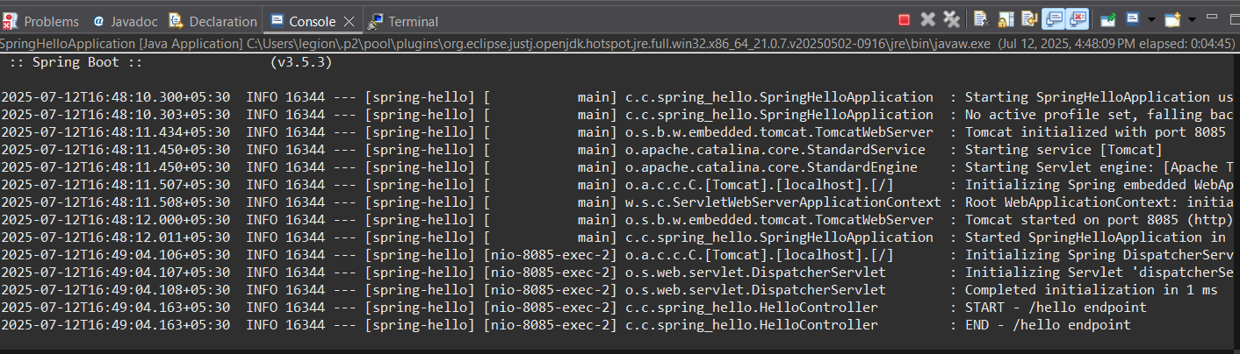

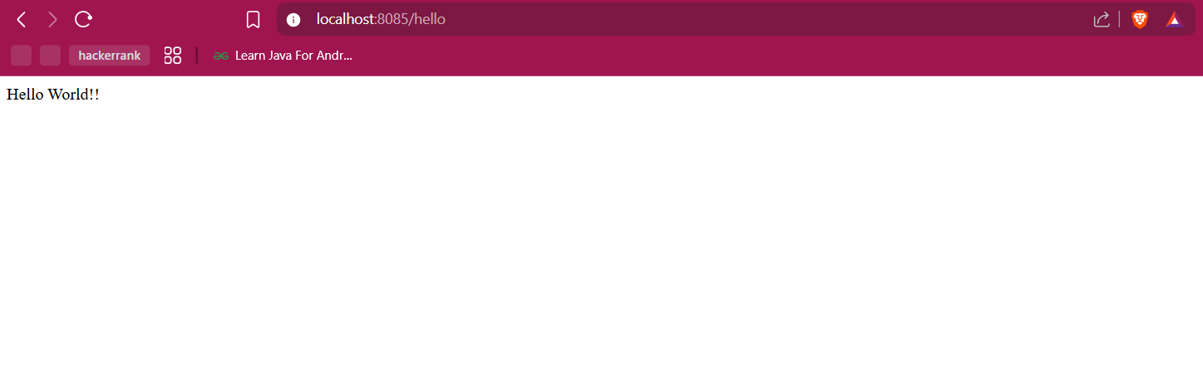

**4.REST - Country Web Service**

**Code:  
country.xml:**<?xml version="1.0" encoding="UTF-8"?>

<beans xmlns="http://www.springframework.org/schema/beans"

xmlns:xsi="http://www.w3.org/2001/XMLSchema-instance"

xsi:schemaLocation="http://www.springframework.org/schema/beans

https://www.springframework.org/schema/beans/spring-beans.xsd">

<bean id="country" class="com.cognizant.springlearn.Country">

<property name="code" value="IN" />

<property name="name" value="India" />

</bean>

</beans>  
**Country.java:**package com.cognizant.springlearn;

public class Country {

private String code;

private String name;

public Country() {

System.out.println("Inside Country Constructor");

}

public String getCode() {

System.out.println("Inside getCode()");

return code;

}

public void setCode(String code) {

System.out.println("Inside setCode()");

this.code = code;

}

public String getName() {

System.out.println("Inside getName()");

return name;

}

public void setName(String name) {

System.out.println("Inside setName()");

this.name = name;

}

@Override

public String toString() {

return "Country [code=" + code + ", name=" + name + "]";

}

}

**SpringLearnApplication.java:**

package com.cognizant.spring_learn;

import org.springframework.boot.SpringApplication;

import org.springframework.boot.autoconfigure.SpringBootApplication;

*@SpringBootApplication*

public class SpringLearnApplication {

public static void main(String[] args) {

SpringApplication.*run*(SpringLearnApplication.class, args);

}

}

**Output:**  
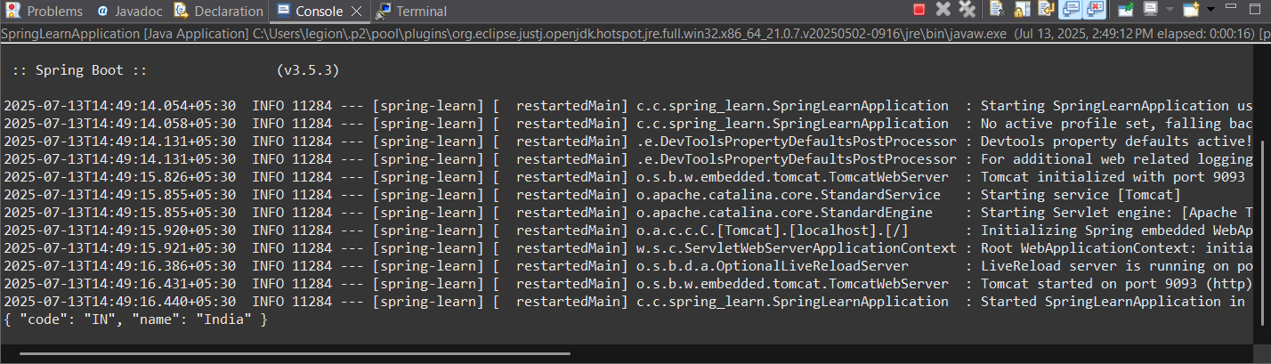

**5.REST - Get country based on country code**

**Code:  
SpringCountryApiApplication.java**

package com.cognizant.spring_country_api;

import org.springframework.boot.SpringApplication;

import org.springframework.boot.autoconfigure.SpringBootApplication;

*@SpringBootApplication*

public class SpringCountryApiApplication {

public static void main(String[] args) {

SpringApplication.*run*(SpringCountryApiApplication.class, args);

}

}

**Country.java:**

package com.cognizant.springcountryapi.model;

public class Country {

private String code;

private String name;

public Country() {}

public Country(String code, String name) {

this.code = code;

this.name = name;

}

public String getCode() {

return code;

}

public void setCode(String code) {

this.code = code;

}

public String getName() {

return name;

}

public void setName(String name) {

this.name = name;

}

*@Override*

public String toString() {

return "Country [code=" + code + ", name=" + name + "]";

}

}

**CountryApplication.java:**  
package com.cognizant.spring_country_api.controller;

import com.cognizant.springcountryapi.model.Country;

import com.cognizant.springcountryapi.service.CountryService;

import org.springframework.beans.factory.annotation.Autowired;

import org.springframework.web.bind.annotation.*;

*@RestController*

public class CountryController {

*@Autowired*

private CountryService countryService;

*@GetMapping*("/countries/{code}")

public Country getCountry(*@PathVariable* String code) {

return countryService.getCountry(code);

}

}

**Countryservice.java:**package com.cognizant.springcountryapi.service;

import com.cognizant.springcountryapi.model.Country;

import org.springframework.context.ApplicationContext;

import org.springframework.context.support.ClassPathXmlApplicationContext;

import org.springframework.stereotype.Service;

import java.util.List;

*@Service*

public class CountryService {

public Country getCountry(String code) {

ApplicationContext context = new ClassPathXmlApplicationContext("country.xml");

List<Country> countryList = context.getBean("countryList", List.class);

return countryList.stream()

.filter(c -> c.getCode().equalsIgnoreCase(code))

.findFirst()

.orElse(null);

}

}

**Country.xml:**<?**xml** version=*"1.0"* encoding=*"UTF-8"*?>

<**beans** xmlns=*"http://www.springframework.org/schema/beans"*

xmlns:xsi=*"http://www.w3.org/2001/XMLSchema-instance"*

xsi:schemaLocation=*"http://www.springframework.org/schema/beans*

*https://www.springframework.org/schema/beans/spring-beans.xsd"*>

<**bean** id=*"countryList"* class=*"java.util.ArrayList"*>

<**constructor-arg**>

<**list**>

<**bean** class=*"com.cognizant.springcountryapi.model.Country"*>

<**property** name=*"code"* value=*"IN"*/>

<**property** name=*"name"* value=*"India"*/>

</**bean**>

<**bean** class=*"com.cognizant.springcountryapi.model.Country"*>

<**property** name=*"code"* value=*"US"*/>

<**property** name=*"name"* value=*"United States"*/>

</**bean**>

<**bean** class=*"com.cognizant.springcountryapi.model.Country"*>

<**property** name=*"code"* value=*"DE"*/>

<**property** name=*"name"* value=*"Germany"*/>

</**bean**>

<**bean** class=*"com.cognizant.springcountryapi.model.Country"*>

<**property** name=*"code"* value=*"JP"*/>

<**property** name=*"name"* value=*"Japan"*/>

</**bean**>

</**list**>

</**constructor-arg**>

</**bean**>

</**beans**>

**Output:**

